
Alexandria University
Faculty of Computers and Data Science
Department: Computing and Data Science
Course Title: Big Data Analytics 2025-2026

Weather Impact on Urban Traffic Analysis

In

Big Data Analytics

Course Code: 02-24-01401

Name:- Mazen Shaban Jomaa ID:- 22010201

Name:- Osama Mohamed Abd-Elshafy ID:- 22010047

Name:- Omar Yahia Ibrahim ID:- 22010174

Name:- Fouad Ramzy Fouad ID:- 22010180
Introduction
This project is about urban traffic analytics under weather conditions aims to design and implement a modern predictive data lake system to analyze how weather conditions affect urban traffic patterns using:
- synthetic data
- MinIO (Bronze / Silver / Gold layers)
- HDFS (as an additional distributed storage layer)
- Python for data processing
- Monte Carlo simulation
- Factor Analysis
It takes a smart city in Lonon, wants to understand how weather conditions (rain, temperature extremes, humidity, wind, visibility) influence traffic behavior and congestion levels, as its scenario. It applies that through 7 phases as follows.

Phase 1: Infrastructure & Data Ingestion (Bronze Layer)
Included writing two Python scripts to generate the two synthetic datasets, weather and traffic, such that keeping the dependencies between columns there to mimic the real-life datasets.
Also, a docker-compose.yml was created to start MinIO server and create three MinIO buckets:
- bronze raw data
- silver cleaned data
- gold final results
The two generated raw datasets uploaded, then, to the bronze layer through the browser console of MinIO on the local host.
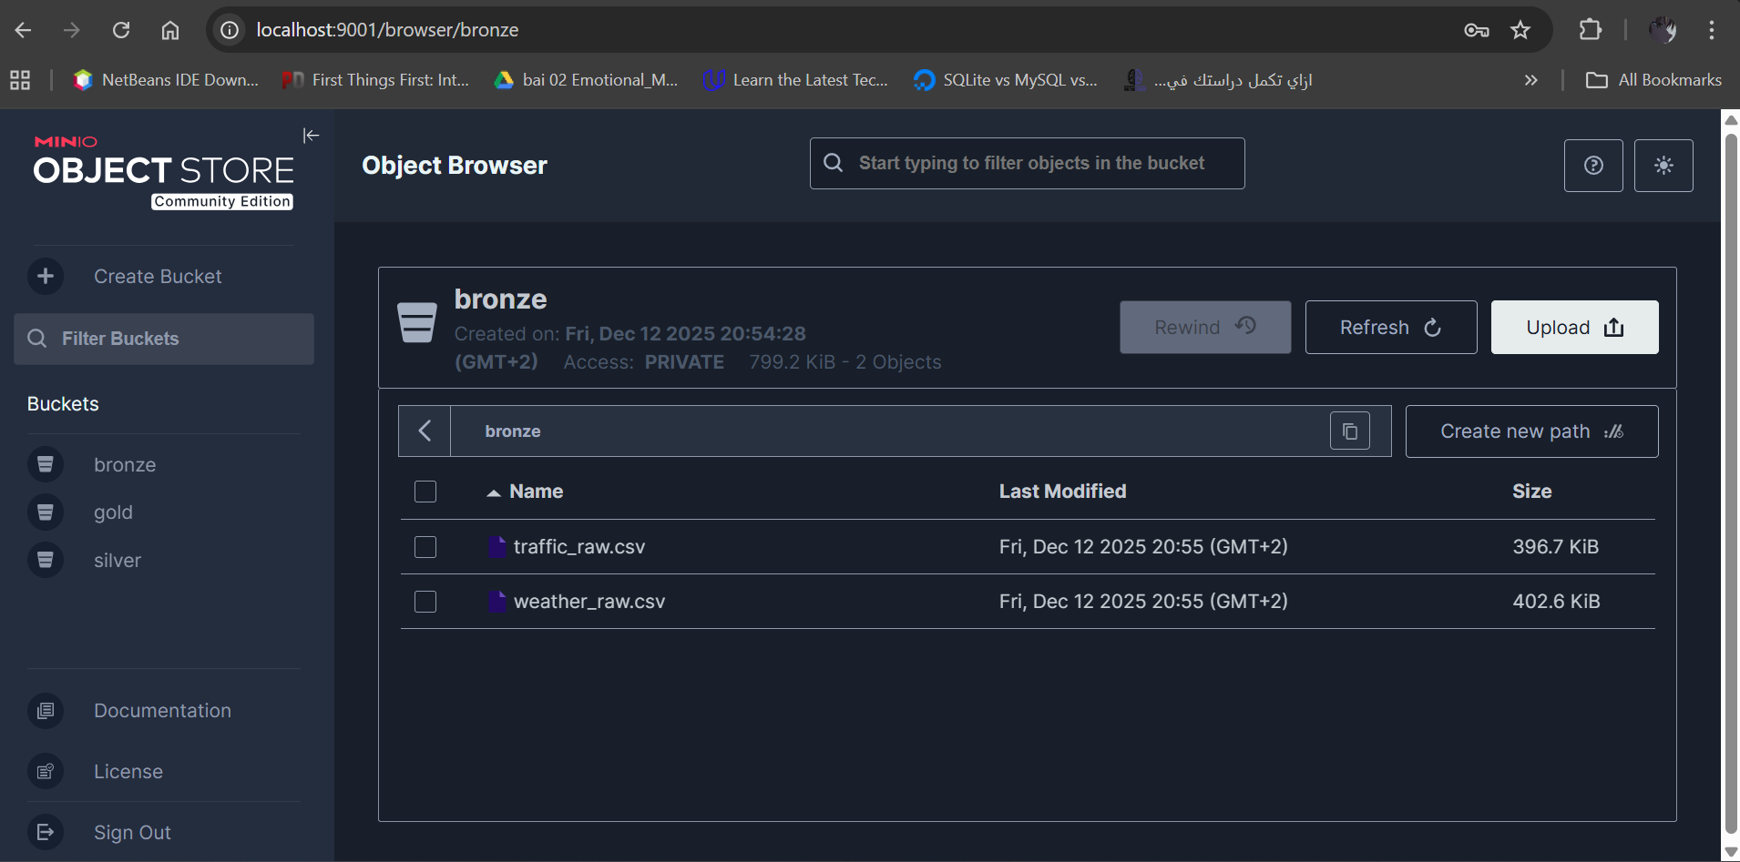
Phase 2: Data Cleaning (Bronze Silver)
Transformed the messy raw data into clean analytical datasets. For each dataset, the process started by imputing the null values according to the problem with a specific column using pattern-based cleaning, XGBoost, etc. Then, it corrected the wrong format of some columns. After that, checking for duplicates which did not exist because of the imputation in the beginning. It, finally, checked for outliers statistically, using IQR, and graphically, using box plots and histograms to handle.
By finishing the cleaning process with no single deleted row, 5250 in 5250 out, both notebooks ended up connecting to the MinIO server to upload the cleaned version of both datasets into the silver bucket of MinIO as parquet files, in addition to saving other copies locally.
More explanation in detail is shown in the notebooks, big data project E(1) V(2).ipynb and big data project traffic data set.ipynb, themselves as markdown cells interpreting the code flow.

Phase 3: HDFS Integration (Additional Storage Layer)
Integrated the Hadoop distributed file system with the data lake using Python script file, ingest_to_hdfs.py, which connects to both, the MinIO and the HDFS servers, fetch the data files from the silver bucket, and streams the data (read RAM write RAM). It opens the MinIO file as a stream and pass it directly to HDFS write storing in the weather_data and traffic_data folders.
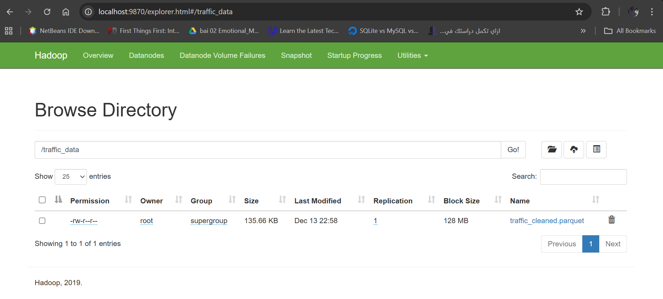
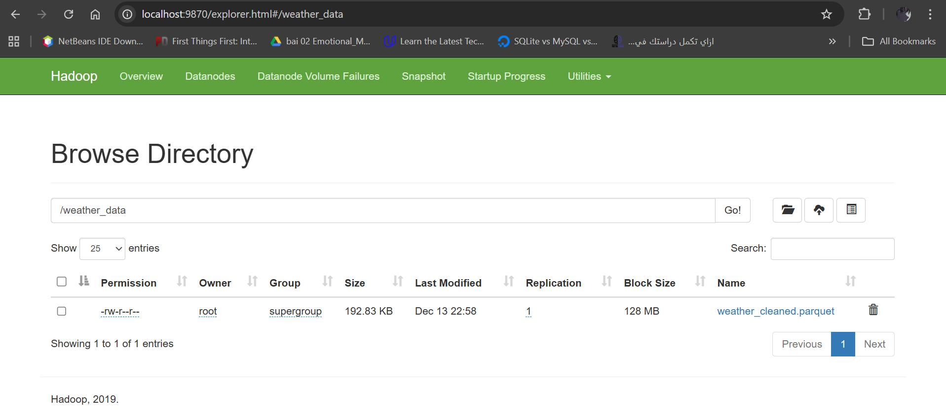
Phase 4: Dataset Merging
To create a unified dataset for analysis, it connects, in the merge_datasets.py Python script, to the silver layer on the MinIO server and read the cleaned version parquet files to apply inner join between them on the “date_time” and “city” columns.
In the end, it uploads the cleaned unified one into the gold bucket on MinIO as a parquet file, as well.

Phase 5: Monte Carlo Simulation (Traffic Risk Prediction)
Simulates the traffic behavior under different weather conditions. It included:
- Heavy rain
- Temperature extremes
- High humidity
- Low visibility
- Strong winds
Its output contained the probabilities of each of “avg_congestion_probability”, “Avg_Accidents_Expected_Per_Batch”, “95%_Confidence_Interval_Congestion”, and “95%_Worst_Case_Accidents” for each of the scenarios above aside with the normal state.
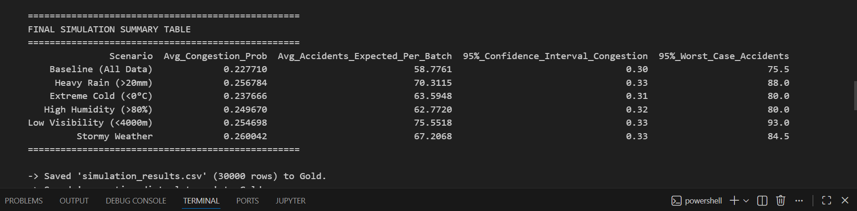
Also, it uploads the dataset resulting in simulation into the gold layer on MinIO as well as the congestion probability distribution plot shown in the figure below.
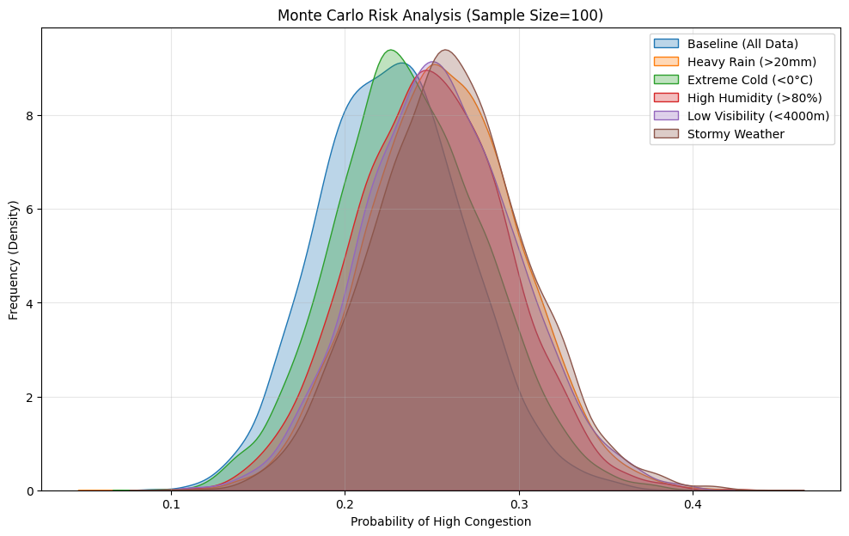
Phase 6: Factor Analysis (Weather Impact Detection)
- Checking factor analysis assumptions:
i) No outliers in the data set Done ✅ [in phase (2)]
ii) Data set size (number of rows) > Number of factors Done ✅ (as required number of factors is from 1 to 3 while data set size is 5250)
iii) Checking whether there is perfect collinearity between features or not Done ✅ [no perfect collinearity], checked in Factor Analysis.ipynb file [and there wasn’t perfect collinearity]
iv) Homoscedasticity between data set features:
- first it wasn’t satisfied, there was heteroscedasticity.
- After applying standardization, it is satisfied ✅

- Stating factor analysis test hypothesis:
- H₀ (Null Hypothesis): The variables in the dataset are uncorrelated = The correlation matrix is an identity matrix
- Hₐ (Alternative Hypothesis): The variables are correlated and suitable for factor analysis

- Testing data set adequacy for factor analysis
- It passed Barlett's sphericity test ✅
- It failed KMO (Kaiser-Meyer-Olkin) test ❌
- We should have stopped Factor analysis but in order to apply phase 7 (Visualization dashboard for factor analysis results & Monte Carlo results) we will continue

- Determining suitable number of factors for the factor analysis
- Using Kaiser criterion approach (statistical approach)
Number of factors=3
- Using scree plot approach (graphical approach)
Number of factors=3

- Factor analysis implementation
i) Using PROMAX Rotation (Oblique rotation):
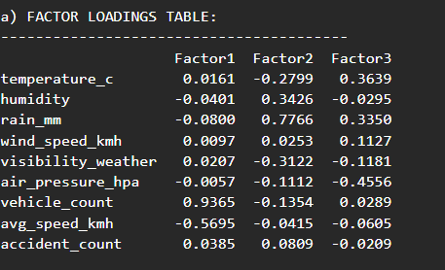
- Factor Loadings values table:

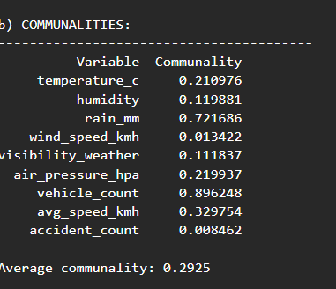
- Communalities values table & average communality value:

- Factor (1):
Name: Traffic Density & Speed Factor
most 2 affecting features/variables: vehicle_count
and avg_speed_kmh
- Factor (2):
Name: Precipitation & Moisture Factor
most 2 affecting features/variables: humidity and rain_mm
- Factor (3):
Name: Temperature-Pressure Gradient
most 2 affecting features/variables: air_pressure_hpa
and temperature_c
ii) Using VARIMAX Rotation (Orthogonal rotation):
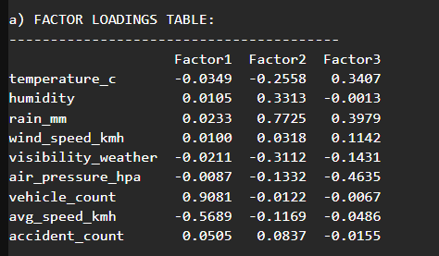
- Factor Loadings values table:

- Communalities values table & average communality value:
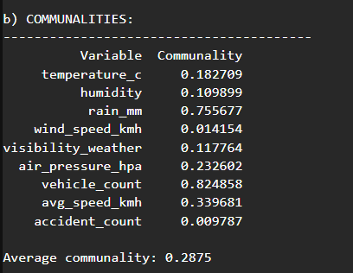
- Factor (1)
Name: Traffic Density & Speed Factor
most 2 affecting features/variables: vehicle_count
and avg_speed_kmh
- Factor (2):
Name: Precipitation & Moisture Factor
most 2 affecting features/variables: humidity and rain_mm
- Factor (3):
Name: Precipitation-Pressure Factor
most 2 affecting features/variables: air_pressure_hpa
and rain_mm
ii) Using QUARTIMAX Rotation (Orthogonal rotation):
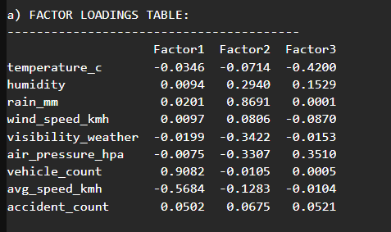
- Factor Loadings values table:

- Communalities values table & average communality value:
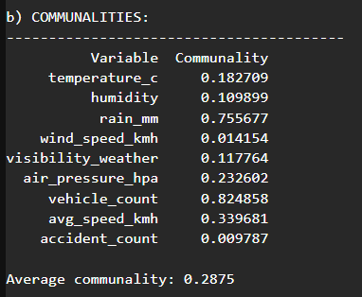
- Factor (1)
Name: Traffic Density & Speed Factor most 2 affecting features/variables: vehicle_count and avg_speed_kmh

- Factor (2):
Name: Low-Visibility Rain Factor most 2 affecting features/variables: visibility_weather and rain_mm
- Factor (3):
Name: Temperature-Pressure Gradient Factor
most 2 affecting features/variables: air_pressure_hpa
and temperature_c

Phase 7 (Optional Bonus): Visualization Dashboard
Streamlit has been used to build two simple interactive web dashboards displaying:
- Cleaned dataset statistics
- Monte Carlo simulation results
- Factor Analysis insights
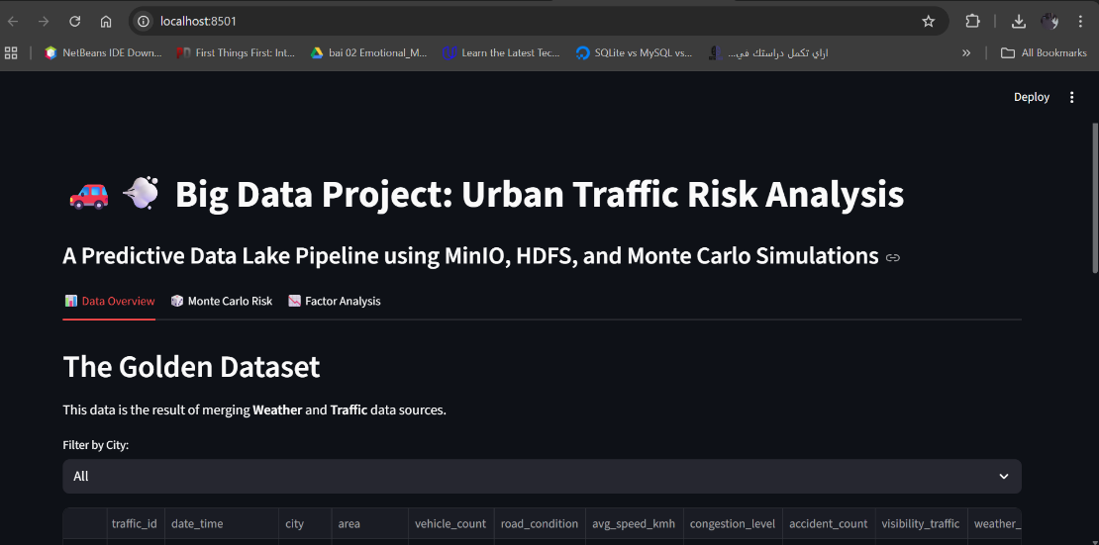

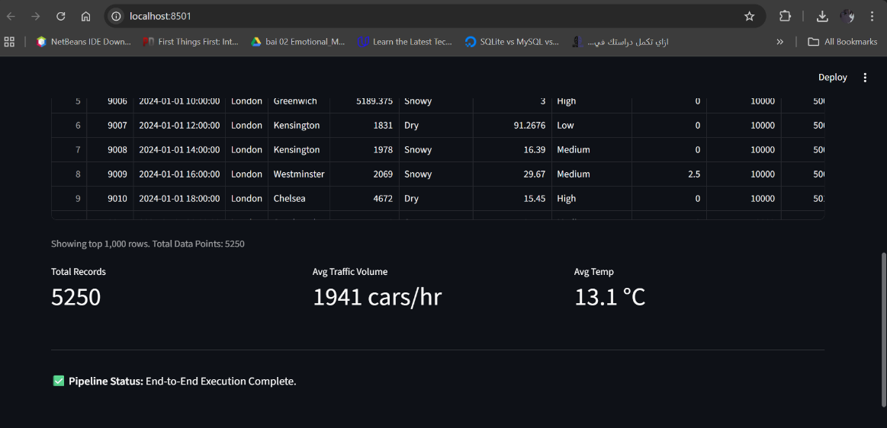

The two figures above show the data overview tab and the overview tab on the other dashboard allows for filtering in case of needing for more specificity about some feature.
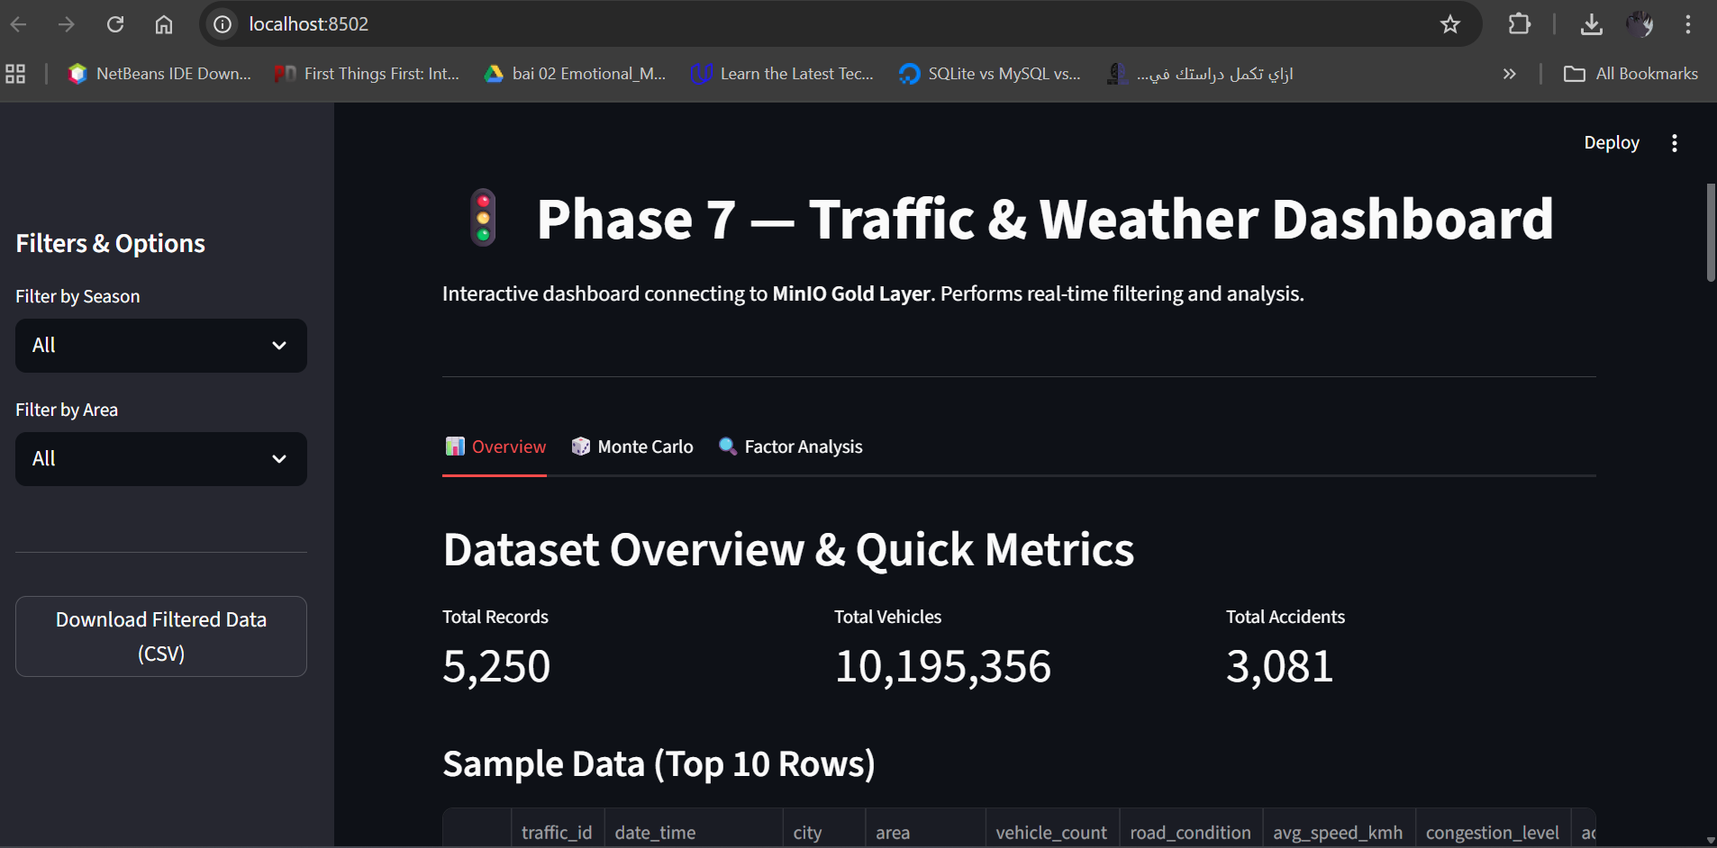

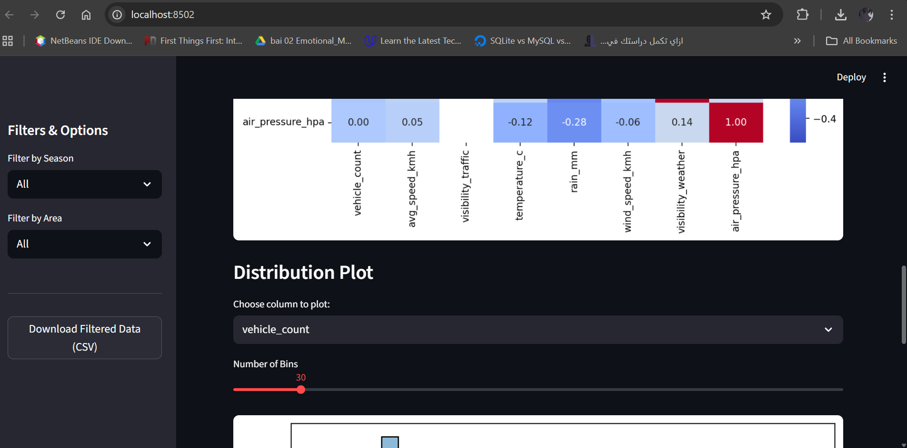
For the Monte Carlo tab, it shows the simulation summary table in addition to a plot for congestion probability in different scenarios.
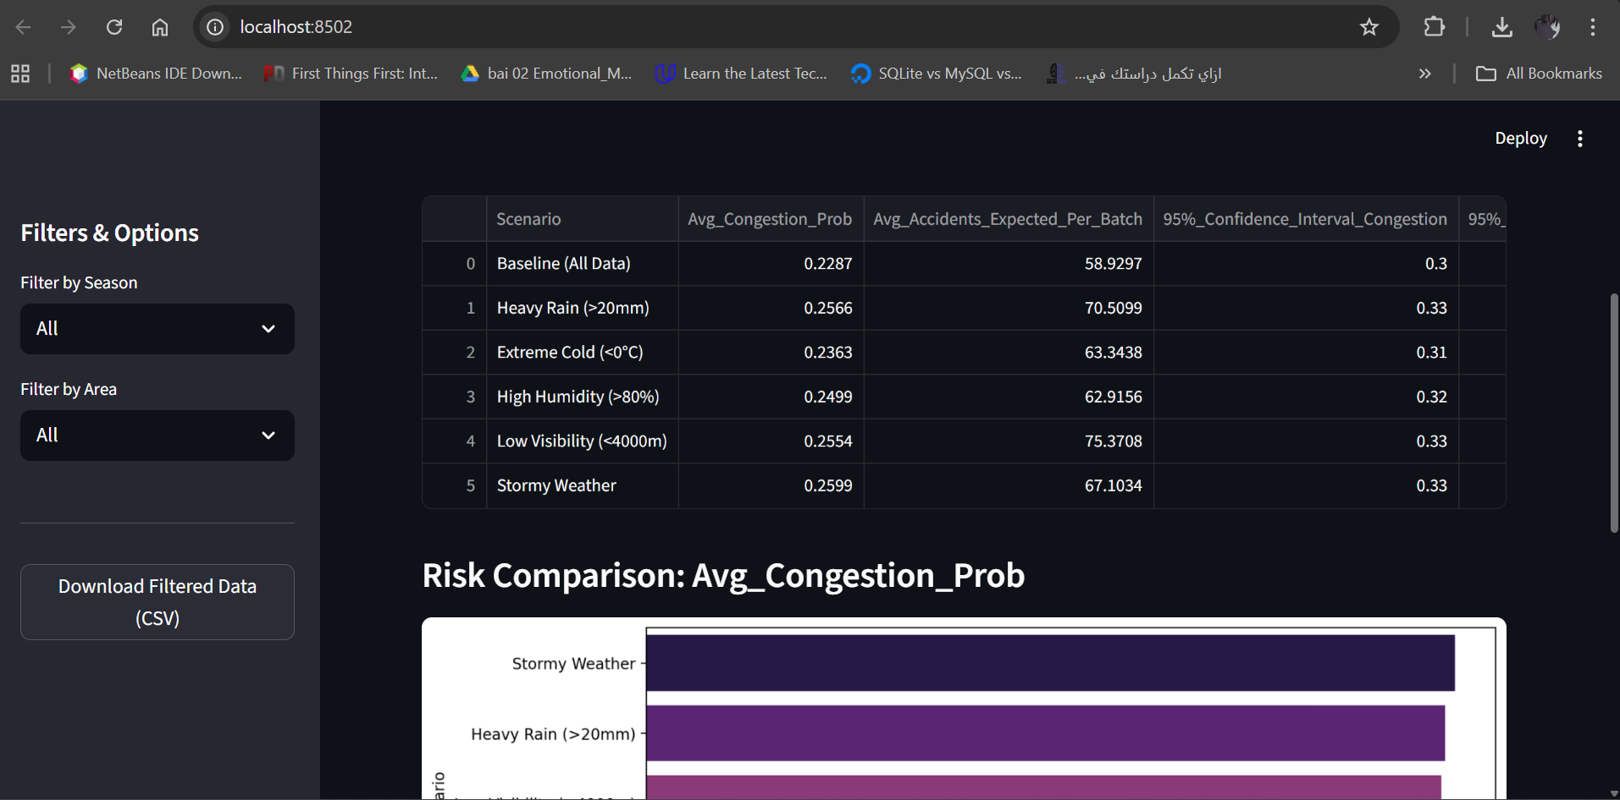
For factor analysis, one dashboard enables users to apply it to some specific features and change the number of extracted factors.
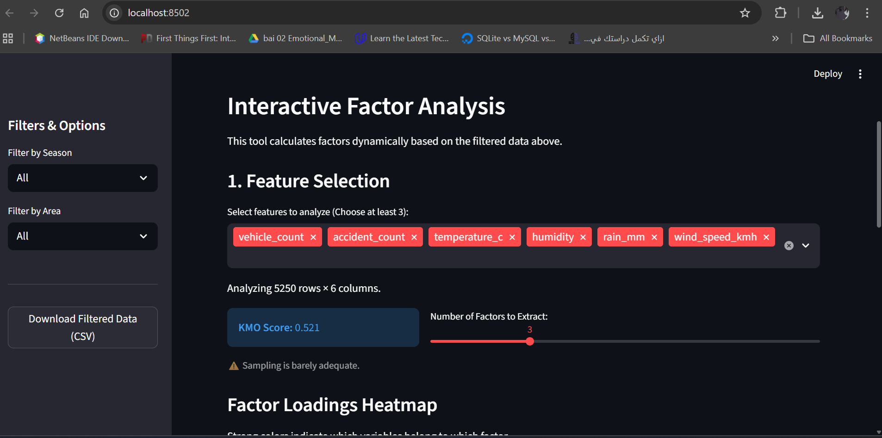
In addition to showing the relationship between each feature and the factors using heatmap as shown below.
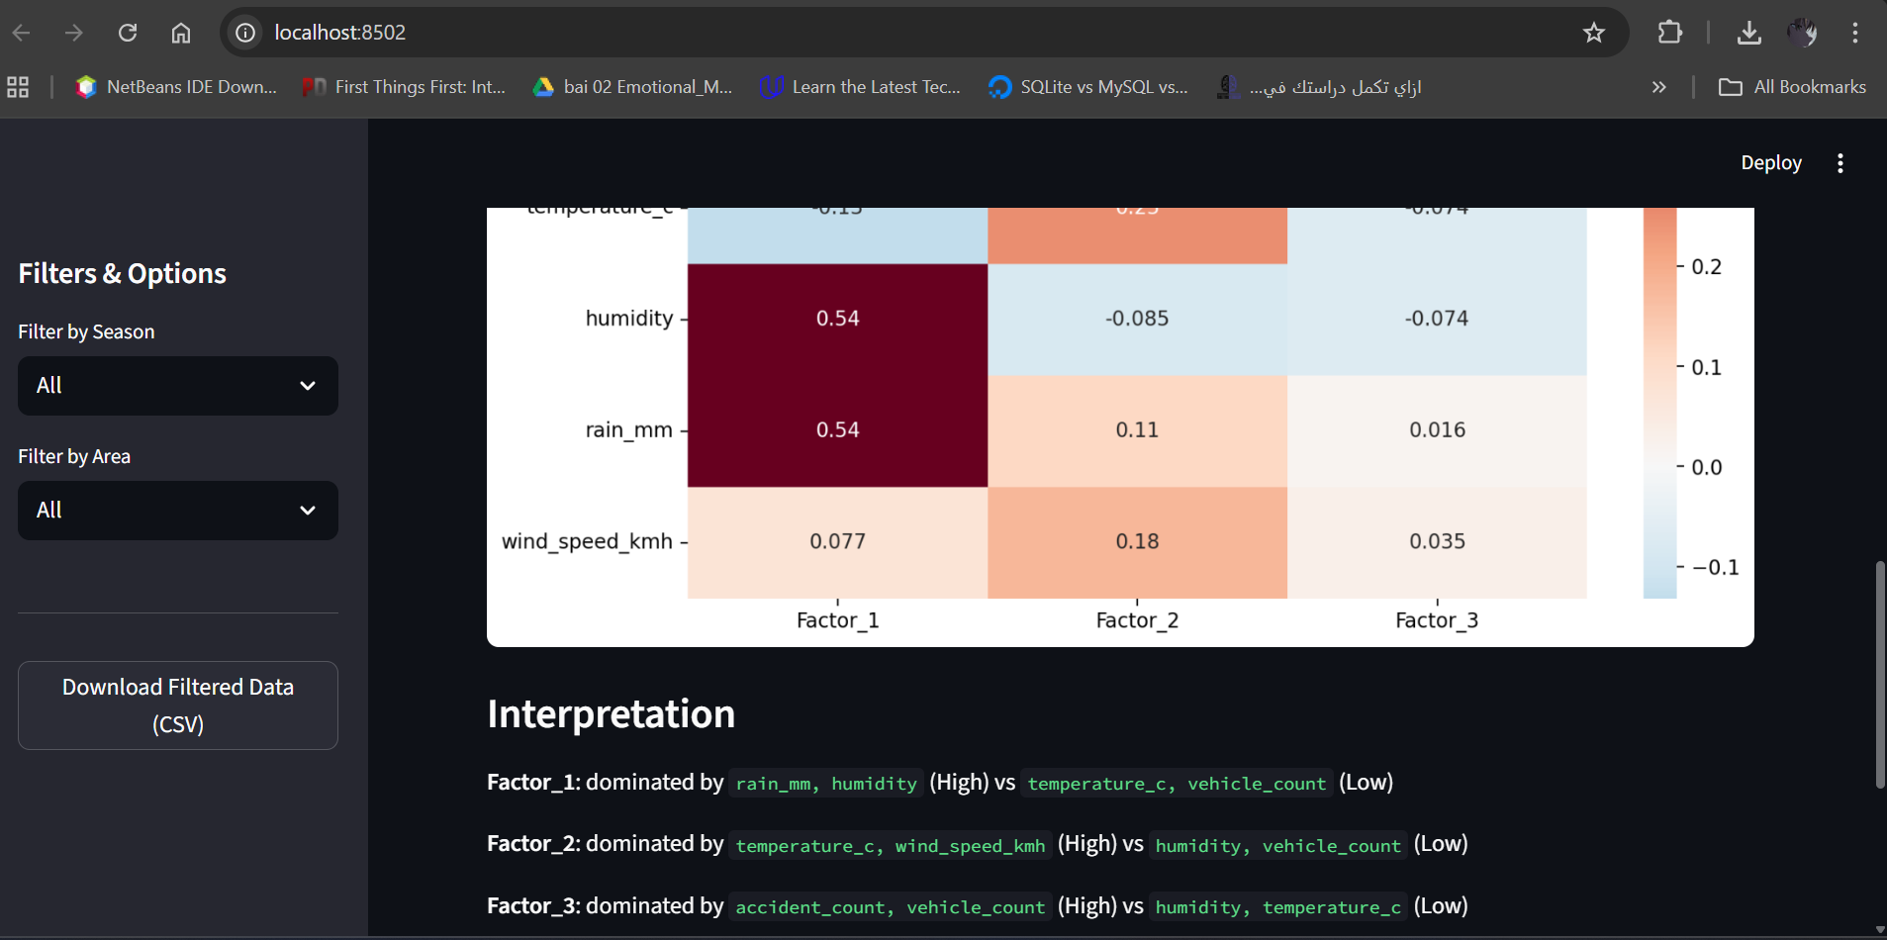
The other dashboard clarifies the eigen value table highlighting the highest three values aside with the scree plot that shows that 3 is the number of factors to extract.
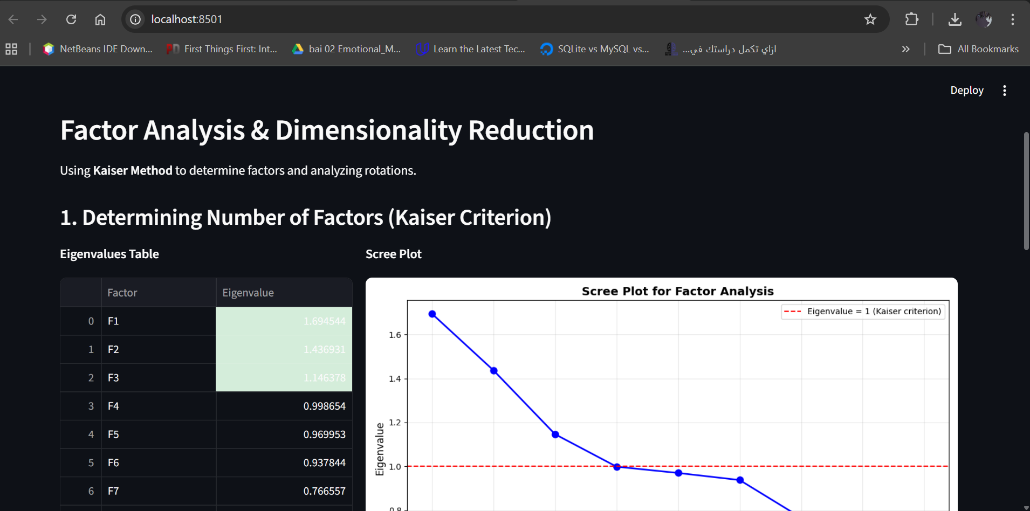
Finally, it shows also each of factor loadings, communalities, and total variance explained tables enabling filtering based on the rotation method (Varimax – Promax – Quartimax)
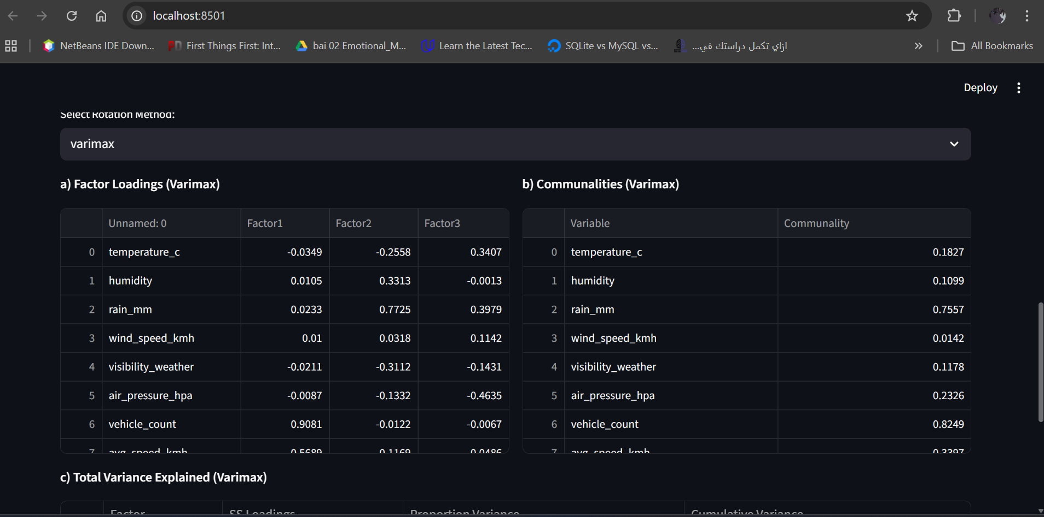

Thank You

